|  |
| --- |
| **Objectives:**   * Solve geometry questions. * Solve trigonometry questions.   ***MONDAY (10.21.24****)* |
| **Discuss the 15 SAT practice questions** assigned on Friday, 10.18, in Google Classroom.  **Class Work/Homework:**  AnglesandPolygons_SATGeometry  Polygons_SATGeometry |

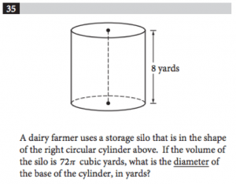

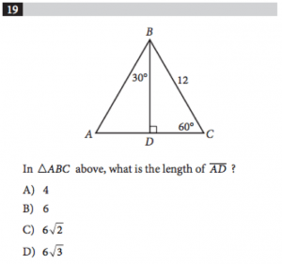

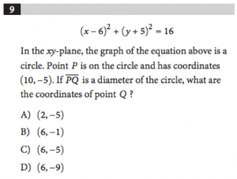

***WEDNESDAY (10.23.24****)*

Discuss the previously assigned SAT questions.

Discussion of right triangle trigonometry.

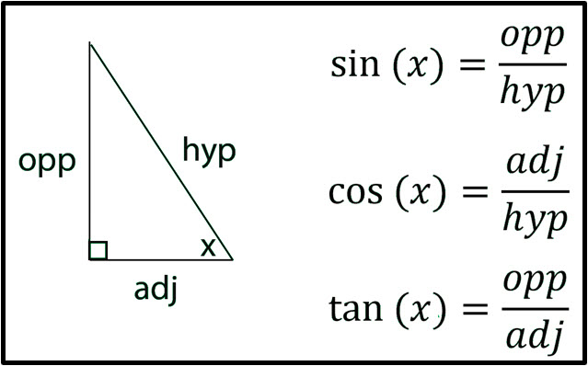

**Class Work/Homework:**

1)**Find the missing sides and angles.  
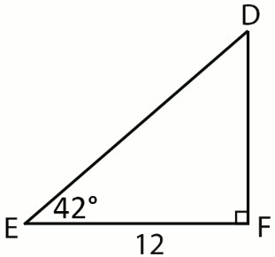**

2)**Find the missing sides and angles.  
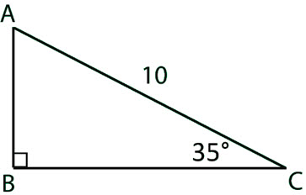**

3)**Find the missing sides and angles.  
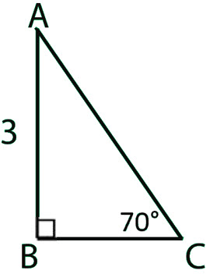**

4)**Express**cos 32∘**in terms of sine.**

5)**Express**sin 48∘**in terms of cosine.**

(6) The base of a ladder is placed 3 feet away from a 10 -foot-high wall, so that the top of the ladder meets the top of the wall. What is the measure of the angle formed by the ladder and the ground?

***FRIDAY (10.25.24****)* **B-DAY, NO CLASS**